HACCP Plan Validation Checklist

Initial Validation (within 12 months of implementation)

Reassessment Validation (due to changes made in production materials or processes)

Annual validation of the HACCP plan

TOPIC | YES | NO | If “YES” Describe | Food Safety Implication | Are modifications to the HACCP System Required?
1. Evaluate product and process
2.Product Description Changed (e.g. intended use by consumer) | 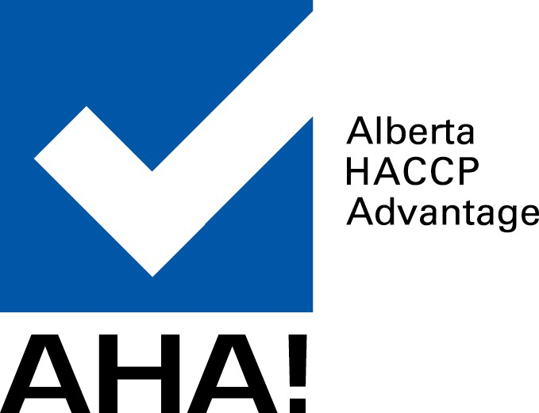
3. Formula Changed?
4. Is the scope an accurate description of the process?
5. Does the flow chart correctly identify each step in the process?
6. Are all significant hazards correctly identified and addressed?
7. Are adequate control measures in place?
8. Have the CCPS/CPs been correctly identified/justified?
9. Are the critical/legal limits acceptable?
10.Are there procedures in place for monitoring?
11.Are corrective actions in place and understood by relevant staff?
12. Are there adequate records in place?
13. Will the plan control all the significant hazards if followed correctly?
14. Ingredients / Packaging Change?
15.Any new product consumption or storage methods?

Other? Describe:

Date Conducted: _________________________________ Date Reviewed: _________________________

Conducted By: _________________________________ Reviewed By: _________________________

